Exercise 2: Verifying Interactions Scenario: You need to ensure that a method is called with specific arguments.

## Steps:

1. Create a mock object.

2. Call the method with specific arguments.

3. Verify the interaction

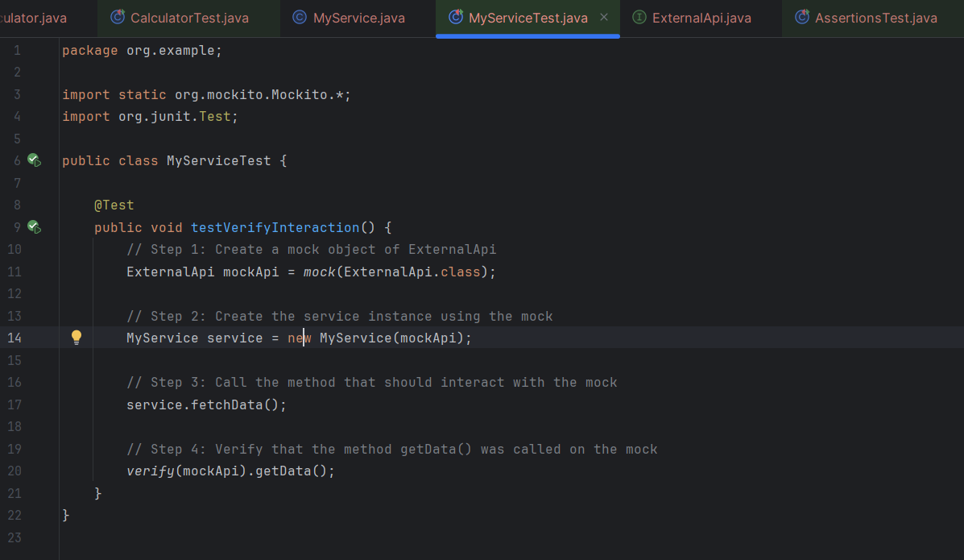

Output-